Abhik Chowdhury

CSE 598: Safe Autonomy of Cyber-Physical Systems

Fall 2021

Homework 4

Translate the system into a zonotope and then plot some trajectories

1.11

initialC = [5.5; 0];

initialG = [.5 0; 0 1];

initialZono = zonotope(initialC, initialG);

1.12

Cp112 = [3.912735892647716;1.444444114378345];

Gp112 = [0.032828275326781 0.355703262967975; 0.612921699955607 0.131313101307122];

Zonop112 = zonotope(Cp112, Gp112);

1.13

Cp113 = [1.540321222096256;1.719742814293046];

Gp113 = [0.039085063961205 .140029202008751; 0.162803212133885 0.156340255844822];

Zonop113 = zonotope(Cp113, Gp113);

1.21 The set of initial conditions

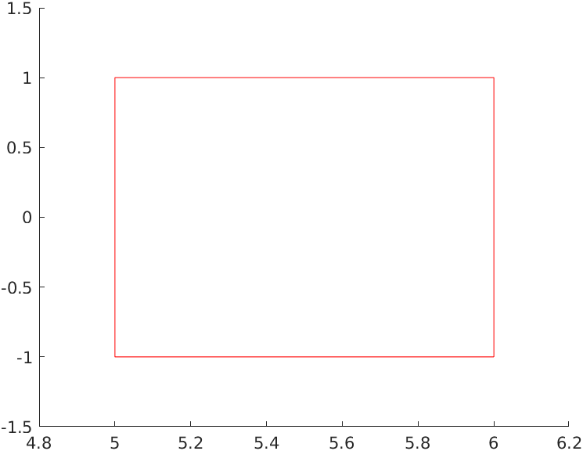

1.22 the set at 0.05

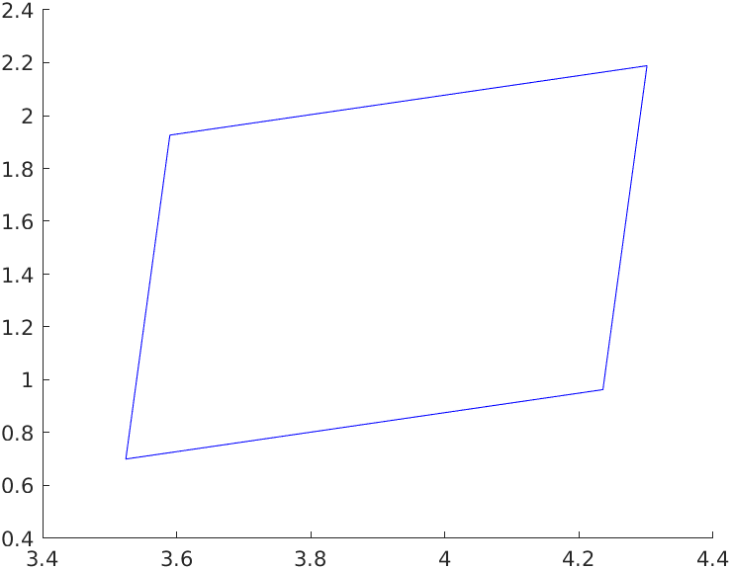

1.23 the set at 0.2

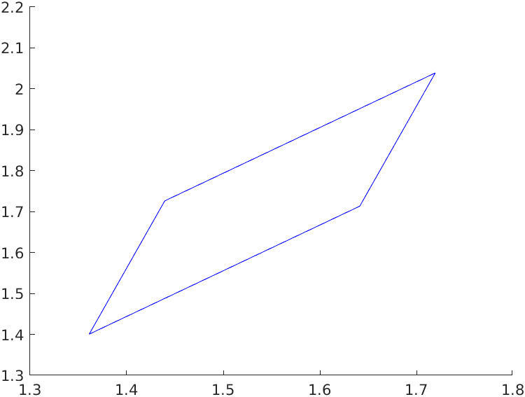

1.24 The trajectories of the system for time 0.2 time units starting from the corners of the set of

initial conditions

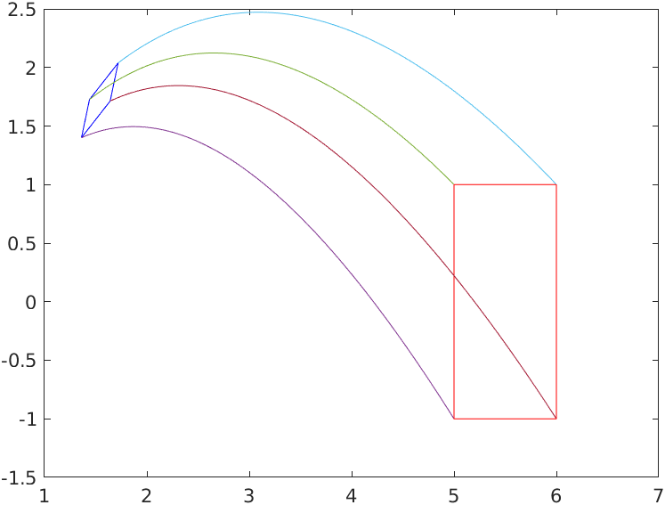

1.30 What do you observe?

The system moves very quickly at the beginning and I had to set the time step very small to capture the initial moments of the trajectory.

2. To show that there are no trajectories that enter the unsafe region I simulated the system with 100 sample trajectories and although they move very fast towards the end none of them go near the unsafe set in the time period specified. I also ran the simulation with 1000 points and got the same result, but in this image you are better able to see the initial set.

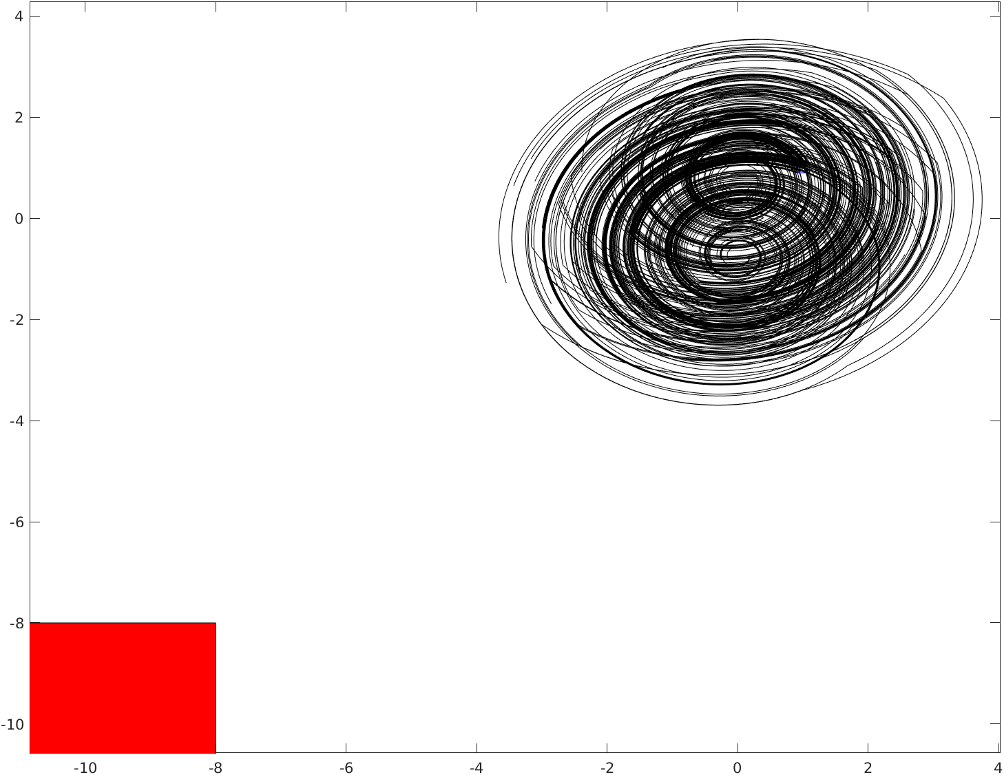

3.1 For the point [1.5; 2] the locally active region is highlighted in red, the highest activation in the region is marked in blue and the original point is marked in green.

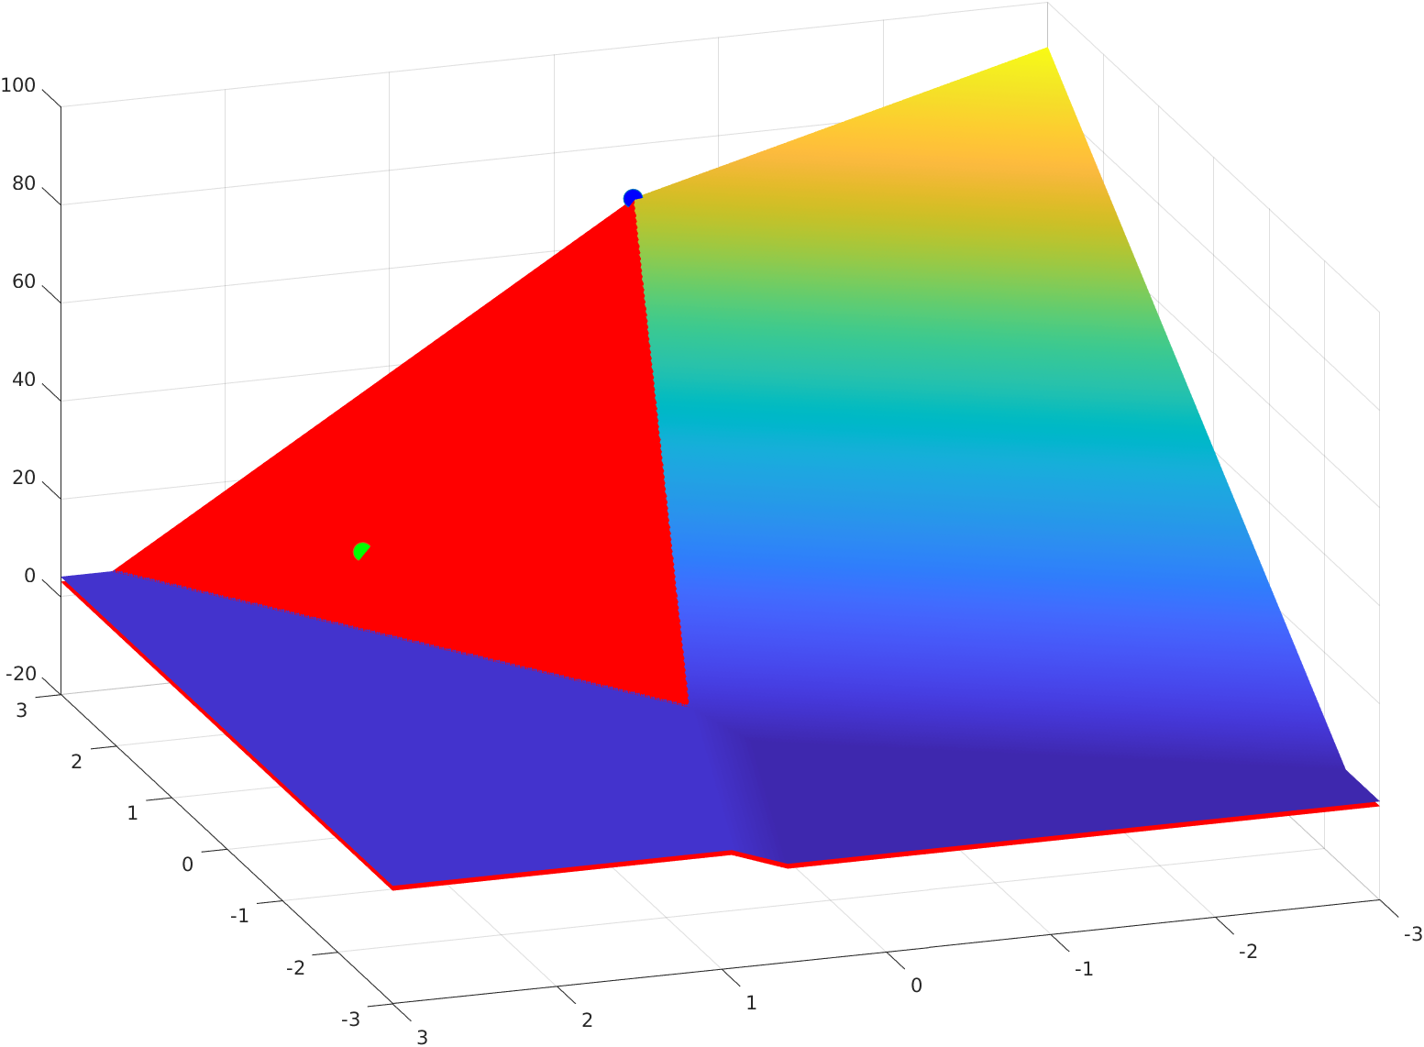

3.2 For the point [0.66; -2.59] the locally active region is highlighted in red, the highest activation in the region is marked in blue and the original point is marked in green.

